Brain Tumor Detection System
Behavioral Modeling

Sequence Diagrams, Activity Diagrams, and State Diagrams

Graduation Project — 2026

Table of Contents

1. Behavioral Modeling Overview
This document presents the complete behavioral modeling for the Brain Tumor Detection and Treatment Suggestion System. Behavioral diagrams describe how the system behaves over time, how objects interact, and how entities transition between states.
This document contains 7 diagrams:
- 3 sequence diagrams — show object-to-object message flows for critical system interactions
- 2 activity diagrams — show workflow and decision logic with parallel processing
- 2 state diagrams — show lifecycle states and transitions for key entities

2. Sequence Diagrams
Sequence diagrams show the chronological order of messages exchanged between objects (lifelines) during a specific interaction. Solid arrows represent synchronous calls, dashed arrows represent return responses, and activation bars show when an object is actively processing.

2.1 SD-01: Scan Submission
This is the most critical sequence diagram in the system. It shows the complete flow when a patient submits an MRI scan for AI analysis, covering all five system participants: Patient, React frontend, Node.js API gateway, FastAPI AI service, and the Database.

Participants: Patient, React, Node.js, FastAPI, Database
Trigger: Patient completes the intake form and uploads an MRI image
Key interactions:
- Steps 1-3: Patient fills the 14-feature form and uploads the MRI file through React
- Step 4: React sends a multipart POST request to Node.js with JWT authentication
- Steps 5-6: Node.js validates the JWT, saves the form data and file path to the database, and creates a scan record with status “processing”
- Step 7: The scan orchestrator forwards the MRI image and 14 patient features to FastAPI via internal HTTP POST
- Steps 8-11 (alt box): FastAPI runs the AI pipeline internally — CNN classifier, U-Net segmenter, location/size/hemisphere extraction, and the treatment suggestion model
- Step 12: FastAPI returns a JSON response containing 7 fields: tumor_type, tumor_location, tumor_size_mm2, hemisphere, treatment_plan, urgency_level, triage_tier
- Steps 13-14: Node.js updates the scan record to “completed” status with results
- Steps 15-16: Node.js returns the results to React, which renders the results page with the triage banner

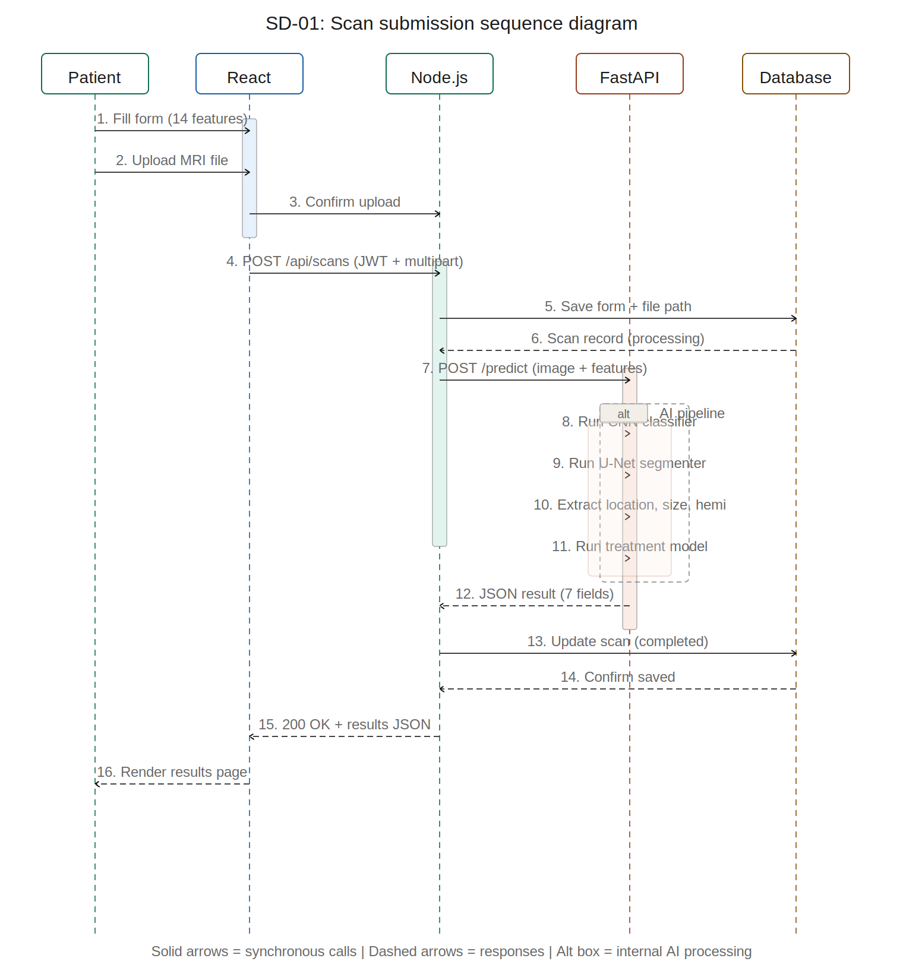
Figure 2.1 — SD-01: Scan submission sequence diagram

2.2 SD-02: Doctor Consultation Flow
This sequence diagram covers the complete consultation lifecycle from the moment a patient books a consultation through the doctor reviewing the AI report and submitting clinical notes.

Participants: Patient, React, Node.js, Doctor, Database
Trigger: Patient selects a doctor and requests a consultation after viewing AI results
Key interactions:
- Steps 1-4: Patient selects a doctor and scan. React sends POST to create consultation. Database stores it with “pending” status
- Step 5: Doctor receives a notification about the new consultation request
- Steps 6-8: Doctor accepts the consultation. Status updates to “accepted”. Patient is notified
- Steps 9-10: Doctor requests the full AI report and patient intake data via GET endpoint
- Steps 11-14: Doctor submits clinical notes with an agreement level (agree/partially agree/disagree). Notes are saved to the database
- Steps 15-17: Patient is notified that notes are available and can view them through the React frontend

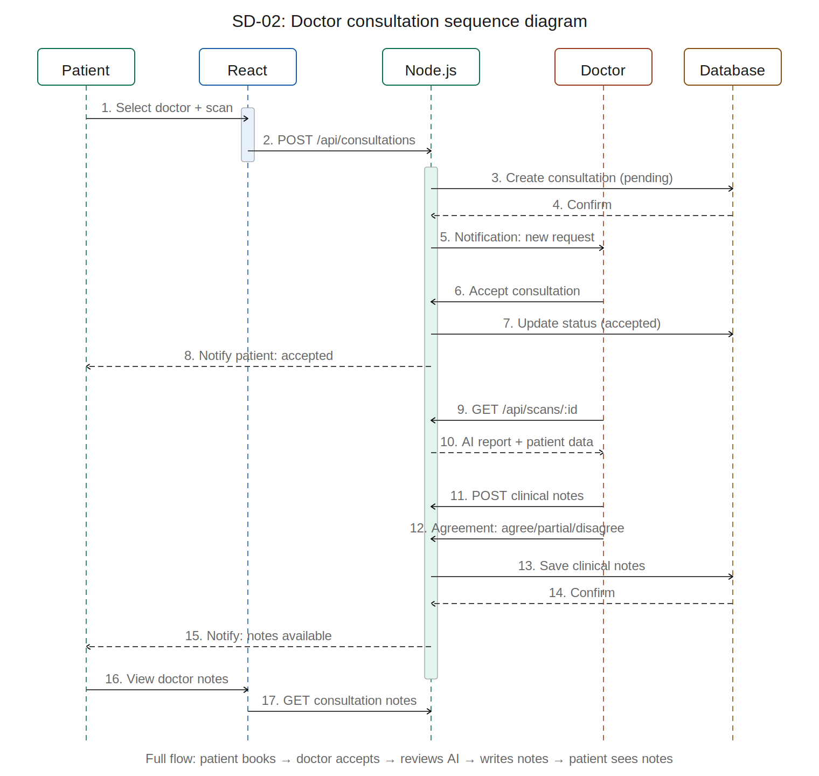
Figure 2.2 — SD-02: Doctor consultation sequence diagram

2.3 SD-03: Doctor Registration and Verification
This sequence diagram shows how a doctor registers on the platform and goes through the admin verification process before becoming visible to patients.

Participants: Doctor, React, Node.js, Admin, Database
Trigger: A doctor visits the registration page and selects the doctor registration path
Key interactions:
- Steps 1-2: Doctor fills registration form with credentials and uploads medical license document
- Steps 3-5: Node.js creates the account with “unverified” status and stores the license file. Database confirms creation
- Step 6: Doctor receives a “registration pending” message
- Steps 7-9: Admin receives notification. Opens the verification queue. Reviews doctor details and license document
- Steps 10-12: Admin approves the doctor. Node.js updates status to “verified” in the database
- Step 13: Doctor receives notification that they are approved and can now appear in patient searches

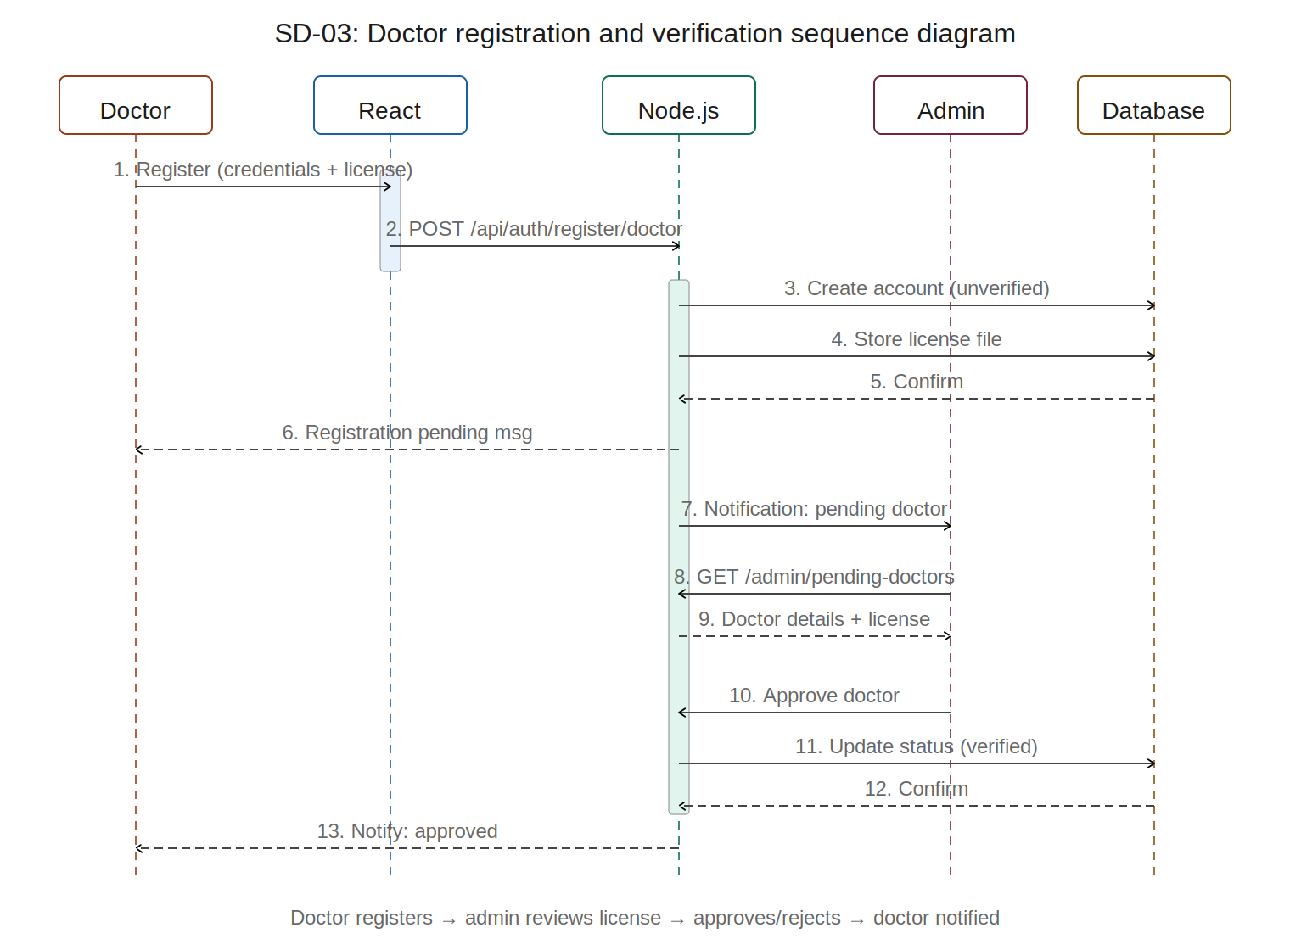
Figure 2.3 — SD-03: Doctor registration and verification sequence diagram

3. Activity Diagrams
Activity diagrams show the flow of activities within a process, including decision points (diamonds), parallel processing (fork/join bars), and branching paths. They are used to model workflows and business logic.

3.1 AD-01: Patient Journey
This activity diagram maps the complete patient journey from first visiting the landing page through receiving AI results and being routed based on triage tier. It is the primary workflow of the entire system.

Key elements:
- Decision point (Valid?): After login attempt, checks if credentials are valid. If no, shows error and loops back to registration. If yes, proceeds to intake form.
- Fork/join bars: After MRI upload, the CNN classifier and U-Net segmenter run in parallel (fork). Both must complete before the treatment model runs (join). This reflects the actual FastAPI implementation.
- Triage decision diamond: After viewing results, the system routes the patient based on triage tier:
- Emergency (red path) → “Seek immediate care” with nearest hospital suggestions
- Urgent (amber path) → “Book consultation” with doctor listing
- Routine (green path) → “Follow up later” at patient convenience
- Merge: All three triage paths converge at the patient dashboard, which serves as the ongoing home for the patient.

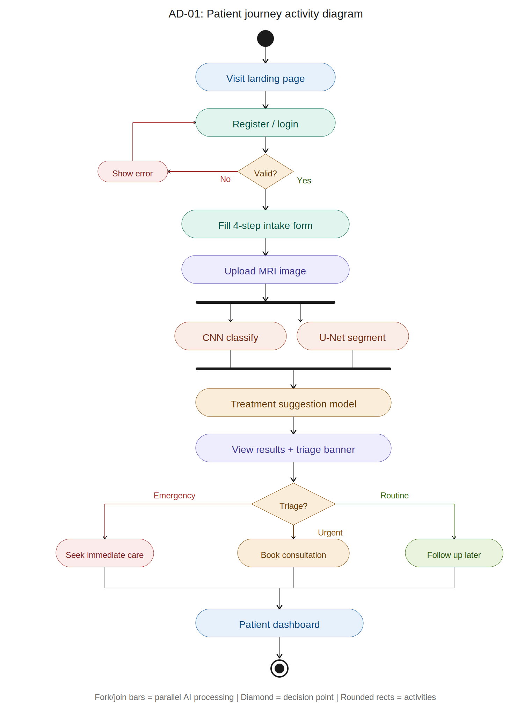
Figure 3.1 — AD-01: Patient journey activity diagram

3.2 AD-02: AI Prediction Pipeline
This activity diagram uses swim lanes to show the internal processing that happens when a scan is submitted. The two lanes separate the Node.js orchestrator responsibilities from the FastAPI AI service responsibilities.

Node.js lane (left):
- Receives the upload request from React
- Validates JWT token and patient role
- Saves form data and file path to database
- Forwards MRI image + 14 features to FastAPI
- Receives results back and saves to database

FastAPI lane (right):
- Preprocesses MRI image into model-ready array
- Forks into parallel paths: CNN classifier and U-Net segmenter
- U-Net path includes three sub-activities: extract tumor location (centroid mapping), calculate tumor size (mm² from mask pixels), and detect hemisphere
- Join bar merges CNN and U-Net outputs
- Treatment model receives the combined 18-feature vector (14 patient + 4 MRI)
- Returns JSON response back to Node.js lane

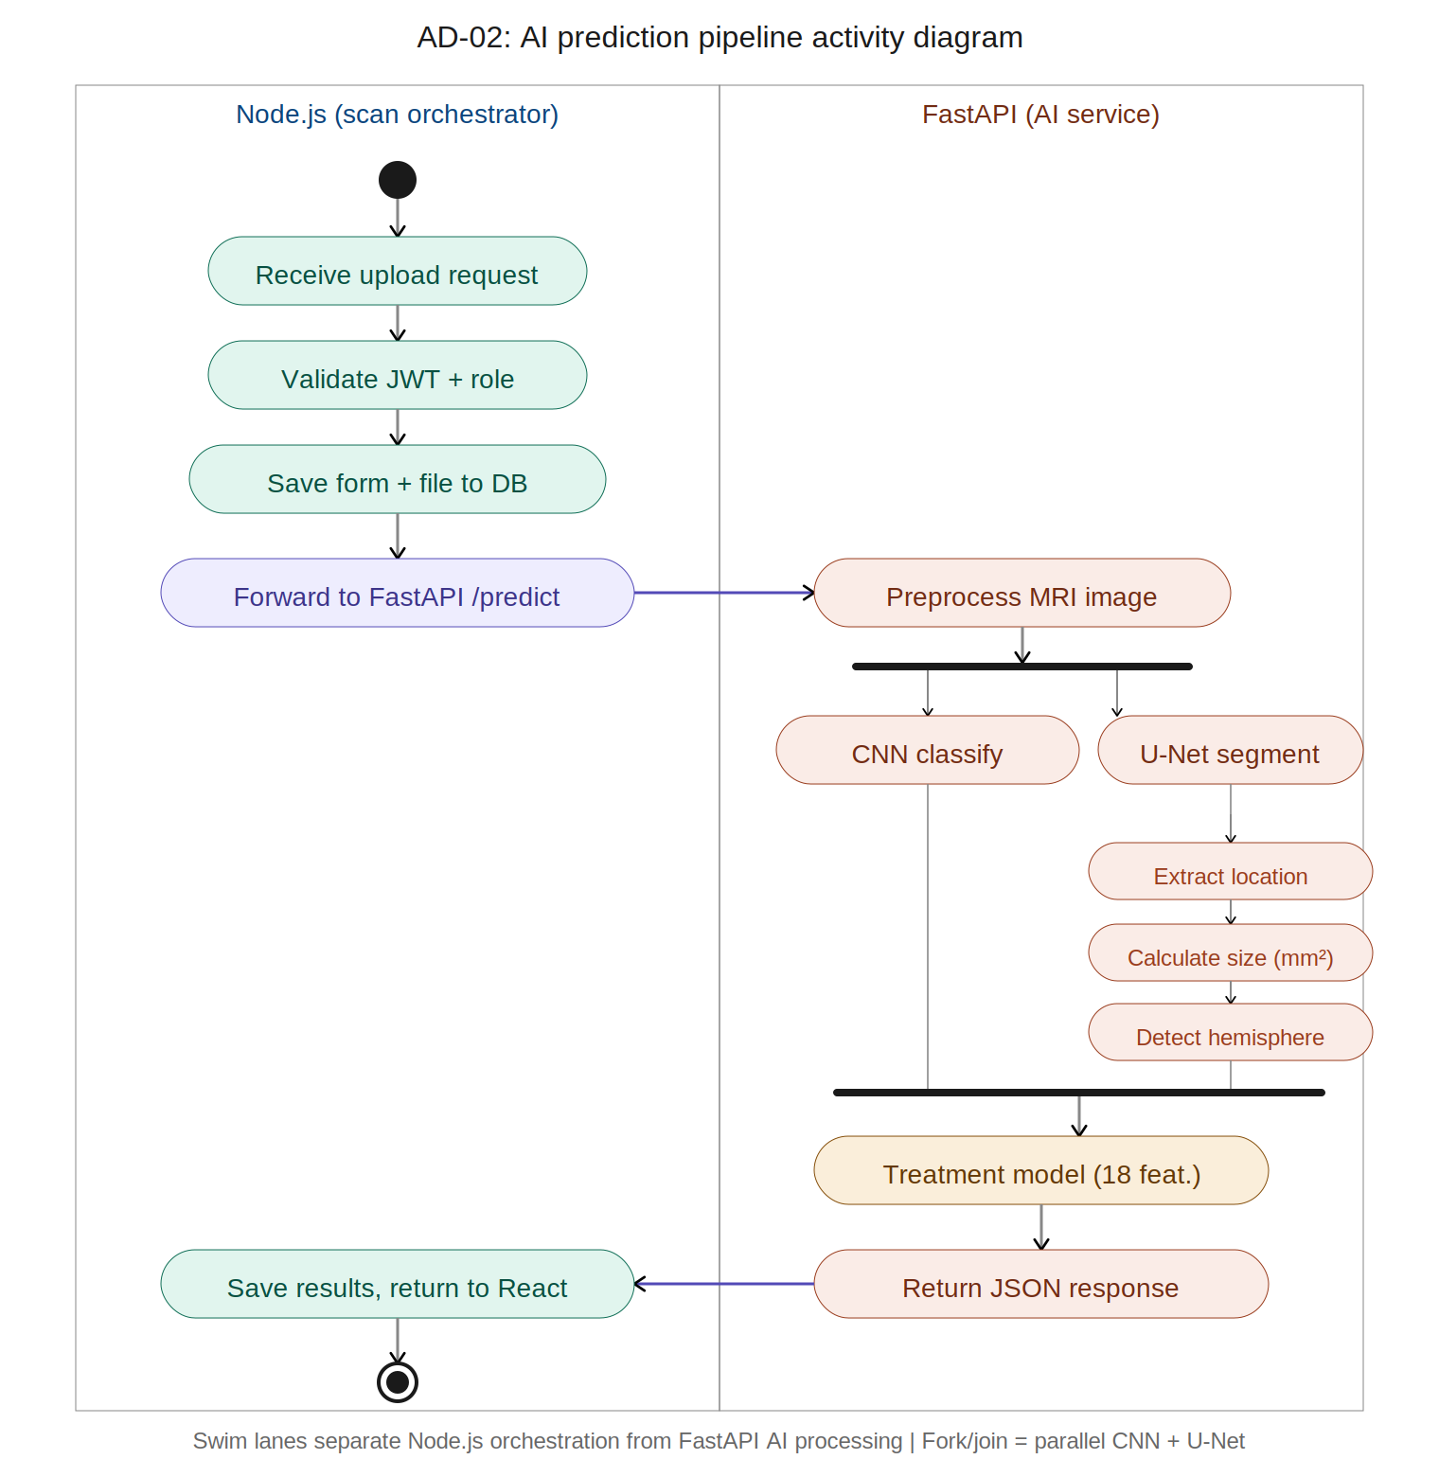
Figure 3.2 — AD-02: AI prediction pipeline activity diagram

4. State Diagrams
State diagrams (also called statechart diagrams) show the lifecycle states of an entity and the events that trigger transitions between states. They are essential for understanding how key objects behave over their lifetime in the system.

4.1 Scan Lifecycle States
The Scan entity transitions through a simple lifecycle with one decision point: whether the AI processing succeeds or fails.

States:
State | Trigger | Description
Created | Patient uploads MRI | Scan record created in database. Form data and file path saved. Status = created.
Processing | Orchestrator forwards to FastAPI | MRI is being analyzed by CNN, U-Net, and treatment models. Loading animation shown to patient.
Completed | FastAPI returns successful result | AI results saved: tumor type, location, size, hemisphere, treatment, urgency, triage. Patient sees results page.
Failed | FastAPI error or timeout | Processing failed. Patient sees error message with retry option. Can optionally retry which returns to Processing.

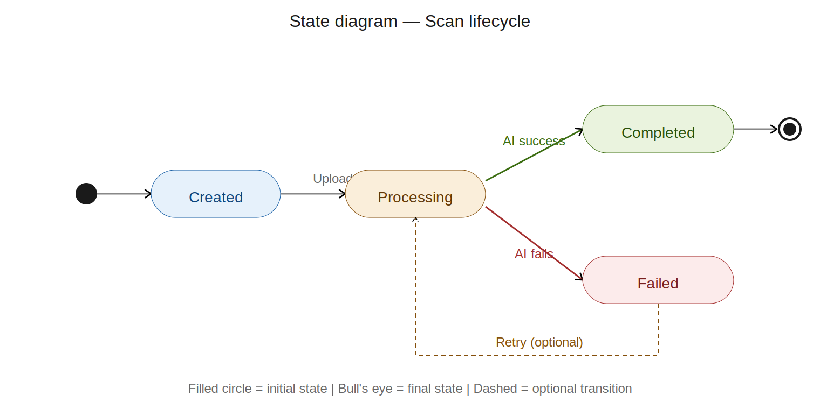
Figure 4.1 — Scan lifecycle state diagram

4.2 Consultation Lifecycle States
The Consultation entity has a more complex lifecycle with multiple decision paths depending on doctor actions.

State | Trigger | Description
Pending | Patient books consultation | Consultation request created. Doctor receives notification. Waiting for doctor response.
Accepted | Doctor clicks accept | Doctor has agreed to review the case. Patient is notified. Doctor can now access the full AI report.
Declined | Doctor clicks decline | Doctor has rejected the request. Patient is notified and can rebook with a different doctor (dashed path back to Pending).
In Progress | Doctor opens AI report | Doctor is actively reviewing the AI analysis and patient data. Writing clinical notes.
Completed | Doctor submits clinical notes | Doctor has finalized their assessment. Notes are visible to patient. Consultation is closed.

Guard conditions: Each transition has a guard condition (shown in square brackets in the diagram) that must be satisfied for the transition to occur. For example, Pending → Accepted requires [doctor clicks accept]. The optional rebook path from Declined back to Pending requires [patient selects a different doctor].

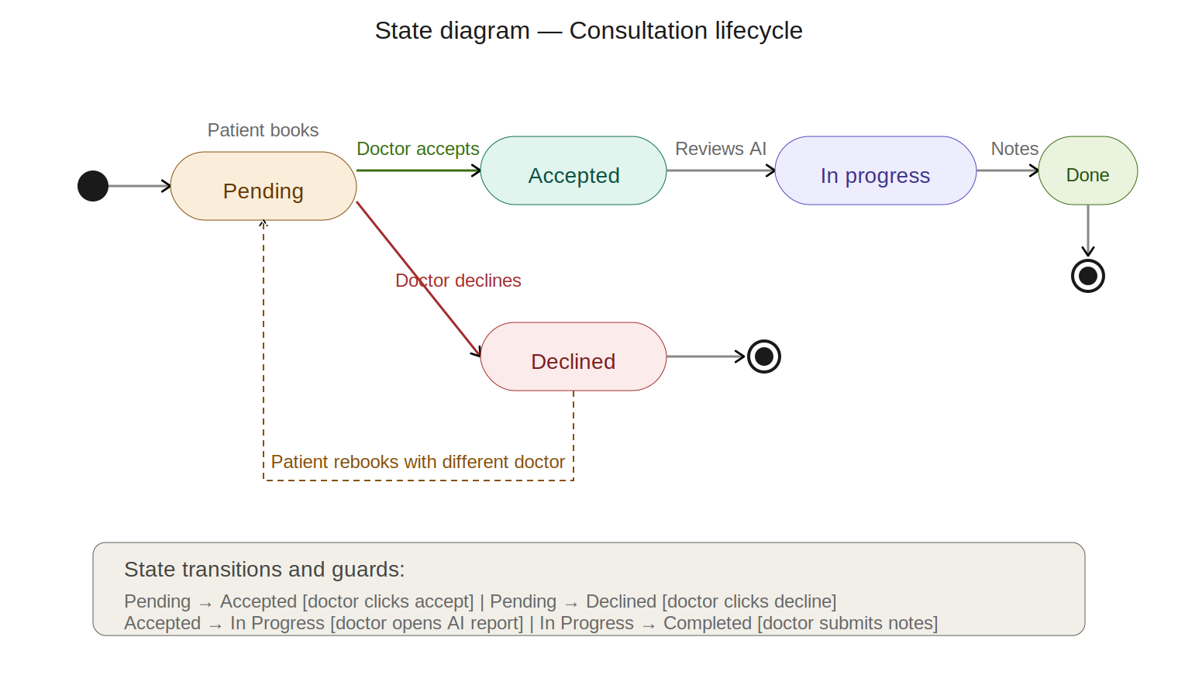
Figure 4.2 — Consultation lifecycle state diagram

5. Behavioral Diagrams Summary
ID | Diagram | Type | Purpose
SD-01 | Scan submission | Sequence | Shows the 16-step flow from patient upload to results display across 5 objects
SD-02 | Consultation flow | Sequence | Shows booking, acceptance, AI review, clinical notes, and patient notification
SD-03 | Doctor verification | Sequence | Shows registration with license, admin review, and approval/rejection
AD-01 | Patient journey | Activity | Full patient workflow with login validation, parallel AI, triage branching
AD-02 | AI pipeline | Activity (swim lanes) | Internal processing split between Node.js orchestrator and FastAPI
ST-01 | Scan lifecycle | State | Created → Processing → Completed/Failed with retry path
ST-02 | Consultation lifecycle | State | Pending → Accepted/Declined → In Progress → Completed

